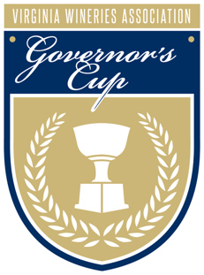
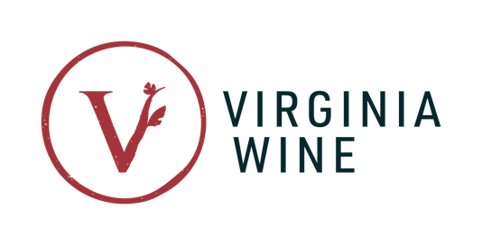

FOR IMMEDIATE RELEASE
Virginia Wine Board Marketing Office
Contact: Annette Boyd
Phone: 804-402-1896
Email: Annette.Boyd@Virginiawine.org

Cana Vineyards Wins 2022 Virginia Governor's Cup® with 2019 Unité Reserve
Winemaker Melanie Natoli Becomes the First Woman to Receive Coveted Cup in Over 20 Years

Richmond, VA (March 24, 2022)– During the annual celebration held at Main Street Station, Governor Glenn Youngkin awarded the 2022 Virginia Governor’s Cup® to Cana Vineyards & Winery of Middleburg for its 2019 Unité Reserve—a signature estate red blend of Merlot, Cabernet Franc and Petit Verdot. In its 40th year, the competition received a record-breaking number of entries—615 wines from over 100 Virginia wineries.

Winemaker Melanie Natoli accepted the prestigious Governor’s Cup® on behalf of Cana Vineyards, joining Debra Vascik of Valhalla Vineyards, who received the honor in 2000, as just the second woman to win the award. Cana Vineyards’ first plantings were in 2012 with Natoli joining as winemaker and vineyard manager in 2015. The 2019 Unité Reserve is a particularly special wine for her as she notes, “it’s in my hands from bud break to bottle.”

“It is an honor to present this year’s Virginia Governor's Cup® to Cana Vineyards and Winery of Middleburg and Melanie Natoli,” said Governor Youngkin. “The 40th anniversary of the competition saw the most diverse selection of award-winning wines to date, demonstrating the passion and experimental spirit of Virginia driving our wine industry to new heights.”

Cana Vineyards’ 2019 Unité Reserve earned the highest average score from a panel of esteemed judges who evaluated the wines based on appearance, aroma, flavor, commercial suitability and overall quality.

The 2019 Unité Reserve will be featured alongside 11 other wines in the Virginia Governor's Cup® Case, a collection of the competition’s 12 highest scoring wines. Cana Vineyards also placed a second meritage blend in the case with its 2019 Le Mariage.

The full case includes:

- Cana Vineyards & Winery of Middleburg 2019 Unité Reserve
- 50 West Vineyards 2019 Ashby Gap
- Barboursville Vineyards 2020 Vermentino Reserve
- Cana Vineyards & Winery of Middleburg 2019 Le Mariage
- Maggie Malick Wine Caves 2020 Albariño
- Michael Shaps Winery 2019 Chardonnay
- Pollak Vineyards 2017 Meritage
- Rockbridge Vineyard 2018 V d'Or
- Shenandoah Vineyards 2019 Reserve Red
- Stinson Vineyards 2017 Meritage
- Trump Winery 2015 Brut Reserve
- Wisdom Oak Winery 2019 NINETEEN

The Virginia Governor's Cup® Case includes a variety of styles and represents three leading wine regions across the Commonwealth: Central Virginia, Northern Virginia and Shenandoah Valley. Seven wines in the case are meritage, Bordeaux-style blends—wines that balance the subtlety of the Old World with the boldness of the new, embodying Virginia’s unique place in the world. Elegant, expressive white varietals also tell the story of this year’s competition with Chardonnay, Vermentino, Albariño, sparkling and a dessert rounding out the case.

For the second consecutive year, Virginia cider was judged in its own category with the highest scoring cider named “Best in Show.” Earning three gold medals in this year’s competition, Albemarle Ciderworks received the top cider recognition for its 2019 Virginia Hewes Crab.

“Virginia wines and ciders continue to cement their place in our exceptional agriculture and tourism industries and as major contributors to the Virginia economy,” said Virginia’s Secretary of Agriculture and Forestry Matt Lohr. “As the state’s oldest operating cidery, this year’s Best in Show Cider winner Albemarle Ciderworks has shown a dedication to bringing locally crafted cider to the table of Virginians everywhere.”

*Edited on June 8, 2022 to note: Debra Vascik of Valhalla Vineyards was the first female winemaker to receive the Virginia Governor’s Cup in 2000 for the 1998 Syrah. The Governor’s Cup® Competition was restructured in 2011 to formalize the judging process with esteemed experts and discern the top twelve wines as the Governor’s Cup® Case. Natoli marks the first female winner of the modern competition recognized today.

About the Virginia Governor’s Cup® Competition

The Virginia Wineries Association’s Governor’s Cup® is held in partnership with the Virginia Wine Board and the Virginia Vineyards Association.

All entries must be made from 100% Virginia-grown fruit to be eligible. Each wine is ranked based on a unified scoring system. For more information about the Virginia Governor’s Cup® Competition and a complete list of winners, visit: www.virginiawine.org/governors-cup.

###

