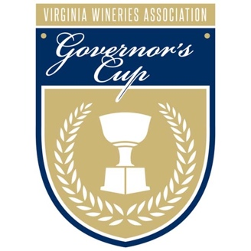
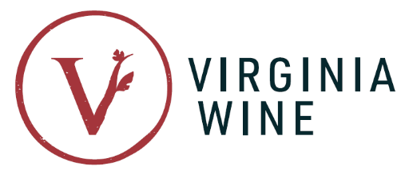

FOR IMMEDIATE RELEASE
Virginia Wine Board Marketing Office
Contact: Annette Boyd
Phone: 804-402-1896
Email: Annette.Boyd@Virginiawine.org

Virginia Wineries Association Announces Virginia Governor's Cup® Gold Medalists

Richmond, VA (March 8, 2022) – Celebrating its 40th anniversary, the Virginia Governor’s Cup® received an unprecedented number of entries from across the Commonwealth. Regarded as one of the nation’s most stringent wine competitions, gold medals have been awarded to 127 wines from 65 Virginia wineries after a series of rigorous blind tastings.

“The Virginia Wineries Association is thrilled to host the 40th year of the Virginia Governor’s Cup®,” said Virginia Wineries Association President George Hodson. “With the most gold medals ever awarded, the 2022 results highlight the industry’s ever-growing commitment to produce the highest quality wines, expressive of Virginia’s grit and experimental spirit.”

To receive a gold medal, a wine must receive an average score of 90 points or higher on a 100-point scale from the competition’s expert panel of world-class judges—led by the esteemed Jay Youmans, MW.

“Each year, it’s incredible to see the diversity of wines the judges favor,” said Youmans. “From the mastery of Meritage blends to the evident understanding of varieties like Petit Verdot and Cabernet Franc and the exploration of unique varieties like Petit Manseng, the caliber of Virginia wines continues to impress.”

In addition to awarding its highest number of gold medals, the year’s competition also saw the highest number of ciders (10) and meads (7) receive this high honor. The winners span the state, with the majority being based in the Central Virginia (29), Northern Virginia (18) and Shenandoah Valley regions (9). For a full list of gold medalists, visit: www.virginiawine.org/governors-cup/awards.

On March 24, the VWA will host the Virginia Governor's Cup® Celebration at Richmond’s Main Street Station to unveil the competition’s top awards—the Governor's Cup® Case, consisting of the 12 highest-scoring red and white wines, Best in Show Cider and the coveted Governor's Cup®. For the first time, this is a ticketed event open to the public. For more information and to purchase tickets, visit: www.exploretock.com/virginiawine/event/319456/2022-virginia-governors-cup-celebration.

Adventurous wine lovers looking to discover Virginia’s best wineries can sign up for the Gold Medal Wine Trail, a mobile passport that includes all 65 gold medal winners. A free resource, passport holders who visit and check-in at participating venues are eligible to receive special offers, discounts and prizes. For more information on the Gold Medal Wine Trail, visit: taste.virginiawine.org.

For interviews and photo requests, please contact Annette Boyd at 802.402.1896 or Annette.Boyd@Virginiawine.org.

About the Virginia Governor’s Cup® Competition

The Virginia Wineries Association’s Governor's Cup® is held in partnership with the Virginia Wine Board and the Virginia Vineyards Association.

All entries must be made from 100% Virginia-grown fruit to be eligible. Each wine is ranked based on a unified scoring system. For more information about the Virginia Governor’s Cup® Competition and for a full list of winners, visit: www.virginiawine.org/governors-cup.

